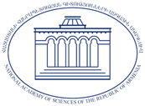
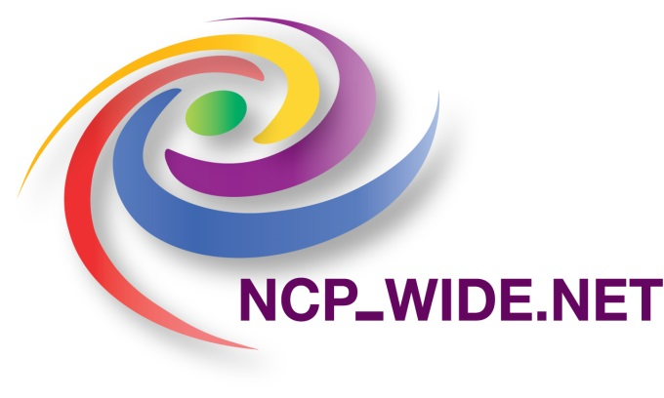
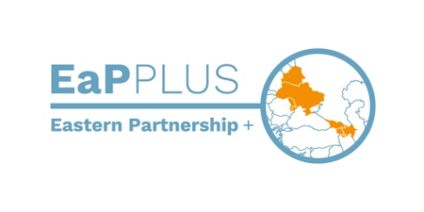

EU H2020 Info Day and Workshop on the Widening Programme

Venue: National Academy of Sciences of Armenia,
24 Baghramian Ave., Yerevan 0019, Armenia

13-14 September 2018

AGENDA

DAY 1
September 13, 2018

9:30 - 10:00 | Registration
10:00-10:30  10:30-10:45 | Official Opening and Welcome Addresses  Hrant Matevosyan, Academician-Secretary, National Academy of Sciences of Armenia  Vardan Sahakyan, Deputy Chairman, State Committe of Science of the Ministry of Education and Science of Armenia (TBD)  Stanislav Toshkov, Programme Manager, the EU Delegation to Armenia (TBD)  H2020 EaP Plus Project Overview and Activities to Support Participation, T. Arzumanyan, ISTPD NAS RA, Widening NCP Armenia
10:45-11:15 | WIDENING Instruments: Twinning - statistics, rules of new calls, conclusions from evaluation process, opportunities for Armenian applicants, T. Arzumanyan, ISTPD NAS RA, Widening NCP Armenia
11:15-11:30  11:30-12:00  12:00-12:15  12:15-12:30  12:30-12:45 | Q&A  Coffee break  NCP_WIDE.NET Project: Assistance to applicants,  W. Adamiak, SEWP NCP Poland, IPPT PAN  Analysis of Armenian Twinning proposal weaknesses – future actions, T. Arzumanyan, Widening NCP Armenia  Polish experience in Twinning calls, W. Adamiak, SEWP NCP Poland, IPPT PAN
12:45-13:00 | Q&A
13:00-14:30 | Networking Lunch
14:30-15:00 | WIDENING Instruments: ERA Chair - statistics, rules of new calls, conclusions from evaluation process, opportunities for Armenian applicants, T. Arzumanyan, Widening NCP Armenia
15:00-15:20  15:20-15:35  15:35-16:00  16:00-16:45  DAY 2 September14, 2018 | Experience of Cyprus Institute in „Twinning“ and „ERA Chair“ Calls, P. Papazoglou, The Cyprus Institute  ERA Chair Polish Experience, W. Adamiak, SEWP NCP Poland, IPPT PAN  Coffee break  Question&Answer session, hands-on support to Armenian proposers
Twinning and ERA Chair Workshop

9:45-10:00 Registration

10:00-11:15 „WIDENING“ Proposal Writing: Hints & Tips, P. Papazoglou, The Cyprus Institute

11:15-11:30 Coffee break

11:30-12:45 „WIDENING“ Proposal Writing: Hints & Tips, (cntd) P. Papazoglou, The Cyprus Institute

13:30 End of the Workshop

14:00-16:00 Individual consultations to Armenian organizations preparing Twinning or ERA Chair proposals for upcomming call

